ICBS Server Applications Administration Basics
ICBS Server Training Material 2
Ver 1.1

OVERVIEW

Familiarization of the Express-O Technology platform on how to perform the installation of the Express-O Server. Additionally, this will also provide basic ICBS Server administration and troubleshooting information for the first level of support.

Table of Contents

OVERVIEW 2
Table of Contents 3
Java Development Kit 5
JDK 7 Installation 5
Downloading the JDK7 Compressed File 5
Installing JDK7 on Ubuntu 5
PostgreSQL Database 8
Installing PostgreSQL 9.6 8
Adding PostgreSQL Apt Repository 8
Installing the PostgreSQL 8
Setting up PostgreSQL 9
Connecting to PSQL CLI 9
Password Management 9
Setting up PostgreSQL configuration file 10
The postgresql.conf file 10
The pg_hba.conf file 10
Backup and Restore thru CLI 12
The pg_dump (Database Backup) 12
Syntax 13
Options 13
Example 14
The pg_restore (Database Restore) 15
Syntax 15
Options 15
Example 16
Glassfish Web Server Application 17
Prerequisites 17
Setting up the Glassfish Web Server 18
Downloading the Application 18
Starting the Application 18
Securing the Application 20
Changing the Password 20
Enabling the Console 20
Configuring Memory Size and Max Thread Pool 21
Glassfish Memory Size 21
Max Thread Pool Size 22
Jasper Reports Web Server 23
Prerequisites 23
Setting up the Jasper Reports Server 24
Downloading the Application 24
Configuring the Application 24
Port number Configuration 26
Service Scripts 27
The /etc/init.d Directory 27
The update-rc.d 27
Creating Script File 28
Service Script for Glassfish 28
Service Script for Jasper Reports Server 30
Basic Troubleshooting 32
Possible Problems on Glassfish 32
Unable to Browse ICBS After changing the IP Address 32
Changing the IP Address on Ubuntu host file 32
Unable to Browse ICBS but can PING the Server 32
Glassfish has not started or has encountered a problem. 32
Error Encountered in WAR file deployment 33
Wrong Database Credentials, IP Address and port 33
Unable to Login on ICBS 33
Web Browser Sessions Issue - Returning to login page after logging-in. 33
Unable to deploy/Undeploy War file on Web Administration Console 34
The Syntax 34
Undeploy Application via CLI 34
Deploy Application via CLI 34
Lack of Memory 34
Possible Problems on PostgreSQL Database Server 35
Long waiting time in Backup processing 35
Cannot Alter or Drop Database 35
The DISCARDALL Script 35
Unable to connect on the database using pgadmin -- 35
Configure the pg_hba.con file 35
Possible Problems on Jasper Reports Server 36
Unable to Login on Jasper Reports Server 36
Long wait on Reports Export and Import 36
Exporting via CLI 36
Importing via CLI 38
Possible Problems on Service Scripts 40
The File is not executable 40
File contains mistyped or wrong declaration of values 40

Java Development Kit

The Java Development Kit aka JDK is an implementation of either one of the Java Platform, Standard Edition, Java Platform, Enterprise Edition, or Java Platform, Micro Edition platforms released by Oracle Corporation in the form of a binary product aimed at Java developers on Solaris, Linux, macOS or Windows.

On this project, we are using JDK version 7.

JDK 7 Installation

Downloading the JDK7 Compressed File

- Download the JDK7 on www.oracle.com. Link Below.

https://www.oracle.com/java/technologies/javase/javase7-archive-downloads.html

- Select the “Linux x86” in the list and click the “jdk-7u80-linux-i586.tar.gz” to download. See the image below.
- After downloading, Copy the downloaded jdk7 file to your server via WinSCP.

Installing JDK7 on Ubuntu
On Linux CLI, find the file “jdk-7u80-linux-i586.tar.gz” and extract to your current working directory.

user@localhost:~$sudo tar xzvf jdk-7u80-linux-i586.tar.gz

Rename the extracted directory to jdk7 and moving it under the /etc/ directory

user@localhost:~$sudo mv jdk1.7.0_80/ jdk7/
user@localhost:~$sudo mv jdk7/ /etc/jdk7

Begin installing the jdk7 on your system by typing the following below.

user@localhost:~$sudo update-alternatives --install /usr/lib/java java /etc/jdk7/bin/java 100
user@localhost:~$sudo update-alternatives --install /usr/lib/javac javac /etc/jdk7/bin/javac 100

Test the installation by viewing the jdk information

user@localhost:~$java -version

Output:

java version "1.7.0_95"
OpenJDK Runtime Environment (IcedTea 2.6.4) (7u95-2.6.4-3)
OpenJDK 64-Bit Server VM (build 24.95-b01, mixed mode)

PostgreSQL Database

PostgreSQL is a powerful, open source object-relational database system that uses and extends the SQL language combined with many features that safely store and scale the most complicated data workloads. The origins of PostgreSQL date back to 1986 as part of the POSTGRES project at the University of California at Berkeley and has more than 30 years of active development on the core platform.

PostgreSQL has earned a strong reputation for its proven architecture, reliability, data integrity, robust feature set, extensibility, and the dedication of the open source community behind the software to consistently deliver performant and innovative solutions. PostgreSQL runs on all major operating systems, has been ACID-compliant since 2001, and has powerful add-ons such as the popular PostGIS geospatial database extender. It is no surprise that PostgreSQL has become the open source relational database of choice for many people and organizations.

Installing PostgreSQL 9.6

Adding PostgreSQL Apt Repository
This will download the repositories of PostgreSQL on your system.

user@localhost:~$sudo sh -c 'echo "deb http://apt.postgresql.org/pub/repos/apt/ `lsb_release -cs`-pgdg main" >> /etc/apt/sources.list.d/pgdg.list'

user@localhost:~$wget -q https://www.postgresql.org/media/keys/ACCC4CF8.asc -O - | sudo apt-key add -

Installing the PostgreSQL
The following command shown below will install the PostgreSQL database on your system.

sudo apt-get update
sudo apt-get install postgresql-9.6 postgresql-contrib

Setting up PostgreSQL

Connecting to PSQL CLI
The command below will allow us to connect in PSQL CLI.

user@localhost:~$sudo -i -u postgres psql

The terminal will show the psql CLI. See below.

psql (9.5.21)
Type "help" for help.

postgres=#

Password Management
Assigning a Password is the first line of securing your database to anonymous users. You can assign or change a database user password by running the command in PSQL CLI as shown below.

postgres=# \password postgres
Enter new password:
Enter it again:
postgres=#
Note: The password does not appear when typing.

Setting up PostgreSQL configuration file

The postgresql.conf file
Configuration parameters in the postgresql.conf file specify server behavior with regards to auditing, authentication, encryption, and other behaviors. The postgresql.conf file resides in the data directory under your Advanced Server installation; you can use your editor of choice to open the postgresql.conf file directly.

- Go to the PostgreSQL directory and edit the postgresql.conf file

user@localhost:~$cd /etc/postgresql/9.6/main/
user@localhost:/etc/postgresql/9.5/main$sudo nano postgresql.conf

- Uncomment and change the listen_address value to “*”. Then ctrl+x to save. See Image Below.
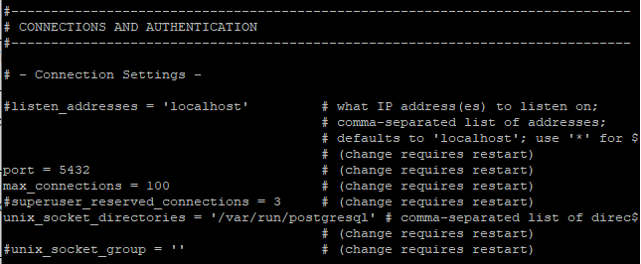
Note: you can also change the port (if necessary) with your desired port number.

The pg_hba.conf file
Client authentication is controlled by a configuration file, which traditionally is named pg_hba.conf and is stored in the database cluster's data directory. (HBA stands for host-based authentication.) A default pg_hba.conf file is installed when the data directory is initialized by initdb.

- Go to the PostgreSQL directory and edit the pg_hba.conf file.

user@localhost:~$cd /etc/postgresql/9.6/main/
user@localhost:/etc/postgresql/9.5/main$sudo nano pg_hba.conf
- Add the following under the “IPv4 local connections” config and ctrl+x to save.

host all all 0.0.0.0/0 md5

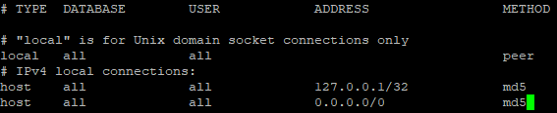

Note: the IP address above is for example purposes only. Please specify the allowed network address that can connect to your postgreSQL app.

- Restart the postgreSQL server after the configuration to make the settings in effect.

Backup and Restore thru CLI

The pg_dump (Database Backup)
pg_dump is a utility for backing up a PostgreSQL database. It makes consistent backups even if the database is being used concurrently. pg_dump does not block other users accessing the database (readers or writers).

pg_dump only dumps a single database. To backup global objects that are common to all databases in a cluster, such as roles and tablespaces, use pg_dumpall.

Dumps can be output in script or archive file formats. Script dumps are plain-text files containing the SQL commands required to reconstruct the database to the state it was in at the time it was saved. To restore from such a script, feed it to psql. Script files can be used to reconstruct the database even on other machines and other architectures; with some modifications, even on other SQL database products.

The alternative archive file formats must be used with pg_restore to rebuild the database. They allow pg_restore to be selective about what is restored, or even to reorder the items prior to being restored. The archive file formats are designed to be portable across architectures.

When used with one of the archive file formats and combined with pg_restore, pg_dump provides a flexible archival and transfer mechanism. pg_dump can be used to backup an entire database, then pg_restore can be used to examine the archive and/or select which parts of the database are to be restored. The most flexible output file formats are the "custom" format (-Fc) and the "directory" format (-Fd). They allow for selection and reordering of all archived items, support parallel restoration, and are compressed by default. The "directory" format is the only format that supports parallel dumps.

While running pg_dump, one should examine the output for any warnings (printed on standard error), especially in light of the limitations listed below.

Syntax

pg_dump [connection-option...] [option...] [dbname]

Options

Options | Description
-d dbname  --dbname=dbname | Specifies the name of the database to connect to. This is equivalent to specifying dbname as the first non-option argument on the command line.  If this parameter contains an = sign or starts with a valid URI prefix (postgresql:// or postgres://), it is treated as a conninfo string. See Section 32.1 for more information.
-h host  --host=host | Specifies the host name of the machine on which the server is running. If the value begins with a slash, it is used as the directory for the Unix domain socket. The default is taken from the PGHOST environment variable, if set, else a Unix domain socket connection is attempted.
-p port  --port=port | Specifies the TCP port or local Unix domain socket file extension on which the server is listening for connections. Defaults to the PGPORT environment variable, if set, or a compiled-in default.
-U username  --username=username | User name to connect as.
-w  --no-password | Never issue a password prompt. If the server requires password authentication and a password is not available by other means such as a .pgpass file, the connection attempt will fail. This option can be useful in batch jobs and scripts where no user is present to enter a password.
-W  --password | Force pg_dump to prompt for a password before connecting to a database.  This option is never essential, since pg_dump will automatically prompt for a password if the server demands password authentication. However, pg_dump will waste a connection attempt finding out that the server wants a password. In some cases it is worth typing -W to avoid the extra connection attempt.
--role=rolename | Specifies a role name to be used to create the dump. This option causes pg_dump to issue a SET ROLE rolename command after connecting to the database. It is useful when the authenticated user (specified by -U) lacks privileges needed by pg_dump, but can switch to a role with the required rights. Some installations have a policy against logging in directly as a superuser, and use of this option allows dumps to be made without violating the policy.

Example
To dump a database into a custom-format archive file:

pg_dump dbname -Fc > /path/to/dbnamefile.backup

To dump a database excluding one or more tables:

pg_dump -h localhost -p 5432 -d dbname -Fc > ~/dbname.backup --exclude-table-data 'table1' --exclude-table-data 'table2' --exclude-table-data 'table3'

The pg_restore (Database Restore)
pg_restore is a utility for restoring a PostgreSQL database from an archive created by pg_dump in one of the non-plain-text formats. It will issue the commands necessary to reconstruct the database to the state it was in at the time it was saved. The archive files also allow pg_restore to be selective about what is restored, or even to reorder the items prior to being restored. The archive files are designed to be portable across architectures.

pg_restore can operate in two modes. If a database name is specified, pg_restore connects to that database and restores archive contents directly into the database. Otherwise, a script containing the SQL commands necessary to rebuild the database is created and written to a file or standard output. This script output is equivalent to the plain text output format of pg_dump. Some of the options controlling the output are therefore analogous to pg_dump options.

Obviously, pg_restore cannot restore information that is not present in the archive file. For instance, if the archive was made using the "dump data as INSERT commands" option, pg_restore will not be able to load the data using COPY statements.

Syntax

pg_restore [connection-option...] [option...] [filename]

Options

Options | Description
-h host  --host=host | Specifies the host name of the machine on which the server is running. If the value begins with a slash, it is used as the directory for the Unix domain socket. The default is taken from the PGHOST environment variable, if set, else a Unix domain socket connection is attempted.
-p port  --port=port | Specifies the TCP port or local Unix domain socket file extension on which the server is listening for connections. Defaults to the PGPORT environment variable, if set, or a compiled-in default.
-U username  --username=username | User name to connect as.
-w  --no-password | Never issue a password prompt. If the server requires password authentication and a password is not available by other means such as a .pgpass file, the connection attempt will fail. This option can be useful in batch jobs and scripts where no user is present to enter a password.
-W  --password | Force pg_restore to prompt for a password before connecting to a database.  This option is never essential, since pg_restore will automatically prompt for a password if the server demands password authentication. However, pg_restore will waste a connection attempt finding out that the server wants a password. In some cases it is worth typing -W to avoid the extra connection attempt.
--role=rolename | Specifies a role name to be used to perform the restore. This option causes pg_restore to issue a SET ROLE rolename command after connecting to the database. It is useful when the authenticated user (specified by -U) lacks privileges needed by pg_restore, but can switch to a role with the required rights. Some installations have a policy against logging in directly as a superuser, and use of this option allows restores to be performed without violating the policy.

Example
To Restore a backup file to a database:

pg_restore -h localhost -p 5432 -d dbname -c /path/to/backupfile.backup

Glassfish Web Server Application

It is an open-source application server project started by Sun Microsystems for the Java EE platform, then sponsored by Oracle Corporation, and now living at the Eclipse Foundation and supported by Payara, Oracle and Red Hat. The supported version under Oracle was called Oracle GlassFish Server.

GlassFish is free software and was initially dual-licensed under two free software licences: The Common Development and Distribution License (CDDL) and the GNU General Public License (GPL) with the classpath exception. After having been transferred to Eclipse, GlassFish remained dual-licensed, but the CCDL license was replaced by the Eclipse Public License (EPL).

The Project ICBS-Express O uses Glassfish 4.1.2. version.

Prerequisites
- JDK7
- Unzip Application

Setting up the Glassfish Web Server

Downloading the Application
- Download the glassfish 4.1.2 compressed file and copy it to the server using WinSCP.

Link:
http://download.java.net/glassfish/4.1.2/release/glassfish-4.1.2.zip

- On the Server, extract the glassfish-4.1.2.zip file to your current working directory.

user@localhost:~$sudo unzip glassfish-4.1.2.zip
Note: for some instance, the unzip tool is not installed on your server. Install the tool by executing this command: sudo apt install unzip

- The extracted directory name of glassfish-4.1.2.zip is glassfish4

Starting the Application
- To start the glassfish web server, go to the extracted glassfish directory and execute the commands shown below.

user@localhost:~$sudo glassfish4/bin/asadmin start-domain domain1
Note: this is to test the glassfish web server application

The output:
Waiting for domain1 to start ..................................................
Successfully started the domain : domain1
domain Location: /home/user/glassfish4/glassfish/domains/domain1
Log File: /home/user/glassfish4/glassfish/domains/domain1/logs/server.log
Admin Port: 4848
Command start-domain executed successfully.

- After executing the app, go to your web browser and check if the application is running. See image below.
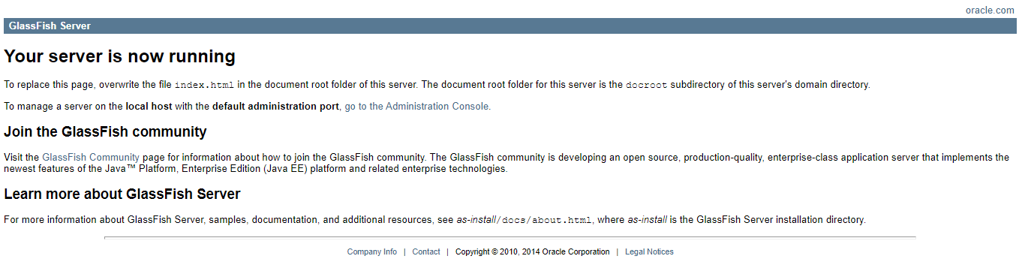
Note: for some instance, you need to set your firewall restrictions for this application.

Securing the Application

Changing the Password
To secure the application, we need to set up a password for your server. Execute the command shown below to change/setup the password.

user@localhost:~$sudo glassfish4/bin/asadmin change-admin-password

user@localhost:~$sudo glassfish4/bin/asadmin change-admin-password
Enter admin user name [default: admin]
Enter the admin password:
Enter the new admin password:
Enter the new admin password again:
Command change-admin-password executed successfully.
Note: leave the “admin username” and “admin password” as blank by pressing enter.

Enabling the Console
To enable the application’s console, run the command shown below.

user@localhost:~$sudo glassfish4/bin/asadmin enable-secure-admin

Fill in the “admin user name” and the “admin password for user”. Restart the glassfish to make the configuration effective.

Enter admin user name> admin
Enter admin password for user "admin">
You must restart all running servers for the change in secure admin to take effect.
Command enable-secure-admin executed successfully.

Browse the glassfish web app to your web browser using the server’s ip address and the console port number.

server_ip_address:4848

Configuring Memory Size and Max Thread Pool

Glassfish Memory Size
This configuration provides more memory to the glassfish web server.

Log onto glassfish web console. Expand the Configurations and server-config tree menu and click “JVM Settings”. See image below.

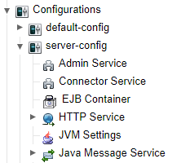

Select the JVM options tab and edit the MaxPermSize and Xmx fields from their default value. The recommended Value for this is 15% of your Server’s Memory. Save the settings and restart the web app server to make the configurations effective.

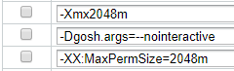

Max Thread Pool Size
Adjusting the Max Thread Pool Size enables the web app to initiate multi threading among the server’s processors. This will ease the incoming connections queuing as well as the outgoing.

- To adjust the Max Thread Pool Size, Go to Configurations, server-config and Thread Pools Tree Menu then select the “http-thread-pool”.

- Change the value of the Max Thread Pool Size to your desired number. Save the configuration to take Effect.

Oversizing the Max Thread Pool Size may lead to a server Malfunction. Extreme Caution is Advised.

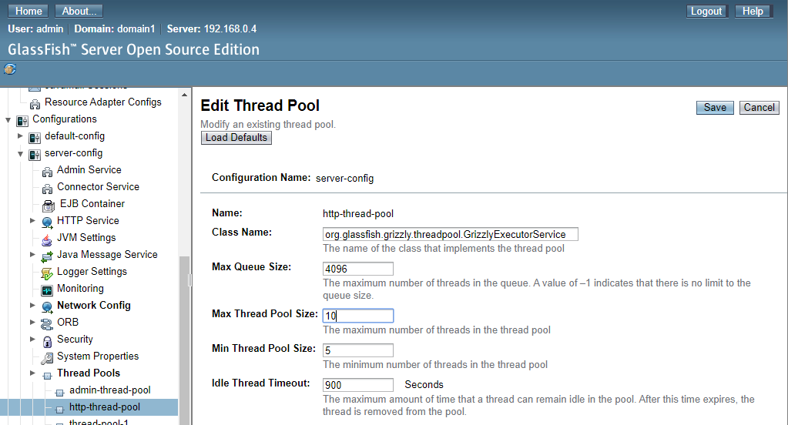

Jasper Reports Web Server

JasperReports Server is a stand-alone and embeddable reporting server, enabling delivery of mission critical information on a real-time or scheduled basis to the web, to the printer, or to a variety of file formats. Build a report in iReport and then deploy it to JasperReports Server.

Prerequisites
- JDK7
- Jasper Reports Server Installer

Setting up the Jasper Reports Server

Downloading the Application
- Go to your web browser and download the Jasper Reports Server 6.3.0. Copy the downloaded file to your server using WinSCP.

Download link:
https://liquidtelecom.dl.sourceforge.net/project/jasperserver/JasperServer/JasperReports%20Server%20Community%20Edition%206.3.0/jasperreports-server-cp-6.3.0-linux-x64-installer.run

Configuring the Application
- Change the file permission to executable. Refer to the command below.

user@localhost:~$sudo chmod a+x jasperreports-server-cp-6.3.0-linux-x64-installer.run

- To Install the application, execute the installer.

user@localhost:~$sudo ./jasperreports-server-cp-6.3.0-linux-x64-installer.run

- The screen will now show the License Agreement of Jasper Reports Server Installer. Skip the agreement until the installer asks you to accept the license. Type “y” and press Enter to proceed.

You are additionally bound by the terms contained in the document entitled
"TIBCO-EULA" and delivered with this software.

Press [Enter] to continue:

You can read an extended license here: /tmp/TIBCO-EULA.txt
Press [Enter] to continue:

Do you accept this license? [y/N]:y

- After the license agreement, the system will ask you to choose on how the Jasper Reports Server to be installed. Choose option 1 to install all the components.

----------------------------------------------------------------------------
JasperReports Server Installation
Please choose an install option below:
[1] Install All Components and Samples (requires disk space of: 1.5 GB)
[2] Custom Install
Please choose an option [1] :

- The installer will ask you to choose where to install the Jasper Reports Server. In this case, we will install it to the default directory given by the installer. Just Press ‘Enter’ to continue.

----------------------------------------------------------------------------
Installation folder
Please, choose a folder to install JasperReports Server CP 6.3.0
Select a folder [/opt/jasperreports-server-cp-6.3.0]:

- The system is ready for the installation. you will be asked again if you want to continue the installation. Just Type “y” and press Enter. Wait for the installation to finish.

----------------------------------------------------------------------------
Setup is now ready to begin installing JasperReports Server CP 6.3.0 on your computer.
Do you want to continue? [Y/n]:y

- Installation Finished. select ‘n’ to cancel information redirect.

Please wait while Setup installs JasperReports Server CP 6.3.0 on your computer.
Installing
0% ______________ 50% ______________ 100%
########################################

Setup has finished installing JasperReports Server 6.3 on your computer.

Opt-in for JasperReports Server Heartbeat
Help us build better products by opting in

For more information please visit:
www.jaspersoft.com/heartbeat
[Y/n]:n

Port number Configuration
It is recommended to set the port number of Jasper Reports Server to avoid conflict with Glassfish Web Application Server.

Go to the installation directory and Edit the server.xml Configuration file of Jasper Reports Server.

user@localhost:~$d /opt/jasperreports-server-cp-6.3.0/apache-tomcat/conf
user@localhost:~$sudo nano server.xml

On the editor, find the ‘Connector port=”8080”’ and change the port to your desired port number. We will be using port number ‘8081’ for this example.

<Connector port="8080" URIEncoding="UTF-8" protocol="HTTP/1.1" connectionTimeout="20000" redirectPort="8443"/>

Save and Restart the Jasper Reports Server to make the configuration effective.

Service Scripts

The /etc/init.d Directory
init.d is the sub-directory of /etc directory in Linux file system. init.d basically contains the bunch of start/stop scripts which are used to control (start,stop,reload,restart) the daemon while the system is running or during boot. If you look at /etc/init.d then you will notice all the scripts for different services of your system.

The scripts within the directory varies as per the applications installed in your system. In the server system you'll find many network related scripts while on the desktop there will be the only basic ones like 'networking'.

Now to control any script, you'll need the superuser (sudo/su) permission. You can manually control the scripts using console/terminal. The syntax for controlling the script is shown below.

/etc/init.d/<script> <option>

Where \<script> stands for the name of the script located under /etc/init.d which you wanna control, and \<option> can be replaced by the control commands like : start,stop,reload,restart,force-reload. See command below.

sudo /etc/init.d/pulseaudio reload

The update-rc.d
updates the System V style init script links /etc/rcrunlevel.d/NNname whose target is the script /etc/init.d/name. These links are run by init when it changes runlevels; they are generally used to start and stop system services such as daemons.

Creating Script File

Service Script for Glassfish
- On Terminal, create a file named glassfish under /etc/init.d. See below.

user@localhost:~$sudo nano /etc/init.d/glassfish

- Type the following script shown below. Change the “AS_JAVA” path to your java installation folder (/etc/java-7-openjdk) as well as the GLASSFISHPATH to the unzipped directory of your glassfish “/home/user/glassfish4/bin” then Save and Exit.

#! /bin/sh
export AS_JAVA=/path/to/jdk7
GLASSFISHPATH=/path/to/glassfish/bin
case "$1" in
start)
echo "starting glassfish from $GLASSFISHPATH"
sudo $GLASSFISHPATH/asadmin start-domain domain1
;;
restart)
$0 stop
$0 start
;;
stop)
echo "stopping glassfish from $GLASSFISHPATH"
sudo $GLASSFISHPATH/asadmin stop-domain domain1
;;
*)
echo $"usage: $0 {start|stop|restart}"
exit 3
;;
esac
:

- After Changing or setting the paths, change the permission of the file to executable. Change the “your_executable_file” to the filename you’ve created.

user@localhost:~$sudo chmod 777 /etc/init.d/your_executable_file

- Use update-rc.d to update and add the executable file to the system automatic services library

user@localhost:~$sudo update-rc.d filename defaults

- Now, try to run the script by executing it. Syntax: sudo service filename start/stop/status. change the filename with your executable filename.

user@localhost:~$sudo service filename start
Note: If there is an error, you can view the message thru sudo service filename status.

Service Script for Jasper Reports Server
- On Terminal, create a file named jasperserver under /etc/init.d. See below.

user@localhost:~$sudo nano /etc/init.d/jasperserver

- Change the “JASPER” path to your jasper reports server installation directory (/opt/jasperreports-server-cp-6.3.0) then Save and Exit.

#! /bin/sh
JASPER="/path/to/jasperReports"
case "$1" in
start)
if [ -f $JASPER/ctlscript.sh ]; then
echo "Starting Jasperserver from $JASPER"
sudo $JASPER/ctlscript.sh start
fi
;;
stop)
if [ -f $JASPER/ctlscript.sh ]; then
echo "Starting Jasperserver from $JASPER"
sudo $JASPER/ctlscript.sh stop
fi
;;
restart)
if [ -f $JASPER/ctlscript.sh ]; then
echo "Restarting Jasperserver from $JASPER"
sudo $JASPER/ctlscript.sh restart
fi
;;
status)
if [ -f $JASPER/ctlscript.sh ]; then
sudo $JASPER/ctlscript.sh status
fi
;;
*)
echo $"usage: $0 {start|stop|restart|status}"
exit 1
;;
esac

- After Changing or setting the paths, change the permission of the file to executable. Change the ‘your_executable_file’ to the filename you’ve created.

user@localhost:~$sudo chmod 777 /etc/init.d/your_executable_file

- Use update-rc.d to update and add the executable file to the system automatic services library

user@localhost:~$sudo update-rc.d filename default

- Start your Jasper Reports Server by using the services scripts. See syntax below.

sudo service <application name> <options>

Options:
- Start
- Stop
- Restart
- Status

Note: If there is an error, run status option.

Basic Troubleshooting

Possible Problems on Glassfish

Unable to Browse ICBS After changing the IP Address

Changing the IP Address on Ubuntu host file
Sometimes after changing the Server’s IP Address, the system does not automatically change the IP Address declared on the Ubuntu host file. This will prevent the user from viewing the web application.

We need to edit the hosts file to change the IP Address declared on the file.

user@localhost:~$sudo nano /etc/hosts

The Editor will display the content of the file. Change your hostname and/or IP Address if necessary then Save and Restart to make the configurations effective.

127.0.0.1 localhost
127.0.1.1 ubuntu-postgresql
# The following lines are desirable for IPv6 capable hosts
::1 localhost ip6-localhost ip6-loopback
ff02::1 ip6-allnodes
ff02::2 ip6-allrouters

Unable to Browse ICBS but can PING the Server

Glassfish has not started or has encountered a problem.
- Check the glassfish status
- If not started, start the glassfish web app server thru services
- If unsuccessful on starting glassfish thru services, start the web app manually.

Error Encountered in WAR file deployment

Wrong Database Credentials, IP Address and port
To Resolve the Error, change the username and password of the database, IP address and Server port in the source code according to the requirements of the client.

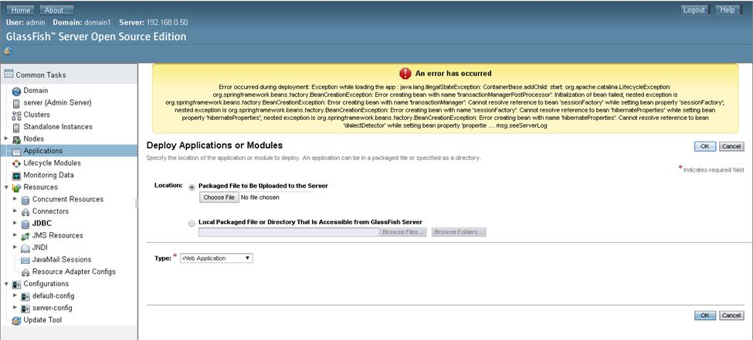

Unable to Login on ICBS

Web Browser Sessions Issue - Returning to login page after logging-in.
When this problem occurs, try to re-open your web browser to clear the sessions of the ICBS.

Unable to deploy/Undeploy War file on Web Administration Console

If you have encountered this problem, you will need to deploy or undeploy the war file thru terminal.

The Syntax

asadmin <options> <application name>

Options:
- deploy
- undeploy

Undeploy Application via CLI
Run the command shown below to undeploy your war file application on the server.

user@localhost:~$sudo glassfish4/bin/asadmin undeploy <WAR file application>

Deploy Application via CLI
Run the command shown below to deploy your war file application on the server.

user@localhost:~$sudo glassfish4/bin/asadmin deploy <WAR file application>
Note: make sure that the WAR file is on the current working directory.

Lack of Memory
You may adjust to a higher value the Maxperm and Xmx Sizes. Oversizing may affect the server performance and can lead to server malfunction. Extreme Caution is advised.

Possible Problems on PostgreSQL Database Server

Long waiting time in Backup processing
Large data from the database may cause long waiting time when performing backups. This technique will shorten the waiting time of the backup process.

Backing up the database first on the local storage of the server will decrease the process time because the database server does not include the network latency on its process.

Cannot Alter or Drop Database

The DISCARDALL Script

DISCARDALL script is a PostgreSQL script that drops all the connections to the database server. This is used when you cannot alter or drop the database because it is currently used.

Syntax
psql <database name> -c "DISCARD ALL";

Command
user@localhost:~$sudo -u postgres psql myDatabase -c “DISCARD ALL”;

Unable to connect on the database using pgadmin --
To resolve this issue, check the pg_hba.conf and postgresql.conf files configurations.

Configure the pg_hba.con file
On pg_hba.conf, check the allowed network IP Address on the list under IPv4. you can add another Network IP Address to gain access. Note: The Network IP Address “0.0.0.0/0” is for testing purposes only.

Configure the postgresql.conf file
On postgresql.conf, check the listen_address network IP Address. you can add and/or change the Network IP Address to gain access via pgadmin. Note: you can use the “*” asterisk symbol to make the “allow all” on your network.

Possible Problems on Jasper Reports Server

Unable to Login on Jasper Reports Server
When this problem occurs, try to re-open your web browser to clear the sessions of the Jasper Reports Server.

Long wait on Reports Export and Import
Due to the volume of reports loaded in your server, you might experience a long waiting time in exporting and importing the reports from your server.

We can work around this issue by Exporting and Importing the backup of Jasper Reports Server via CLI.

Exporting via CLI
On CLI, locate your Jasper Reports Server installation directory and find the js-export.sh executable file under buildomatic directory. See syntax and commands shown below.

Syntax
js.export.sh <OPTIONS> <PathToDirectory>

Command
user@localhost:~$cd /opt/jasperreports-server-cp-6.3.0/buildomatic/
user@localhost:/opt/jasperreports-server-cp-6.3.0/buildomatic/$sudo ./js-export.sh --everything --output-zip ~/export.zip

Export Options
Options | Descriptions
--everything | Export everything except audit and monitoring data: all repository resources, permissions, report jobs, users, and roles. If any server settings have been modified in the UI, those are included as well.  This option is equivalent to:  --uris --repository-permissions --report-jobs --calendars --users --roles
--help | Displays brief information about the available options.
--include-access-events | Access events (date, time, and user name of last modification) are exported.
--output-dir | Path of a directory in which to create the output catalog folder.
--output-zip | Path and filename of the output catalog zip file to create.
--report-jobs | Comma separated list of repository report unit and folder URIs for which report unit jobs should be exported. For a folder URI, this option exports the scheduled jobs of all reports in the folder and recursively in all subfolders.
--calendars | When specified, the export will include any and all calendars of all types (holiday, recurring, ...) defined in the scheduler. When calendars are present in an export catalog, they are always processed and added upon import.
--repository-permissions | When this option is present, repository permissions are exported along with each exported folder and resource.  This option should only be used in conjunction with --uris.
--roles | Comma separated list of roles to export; if no roles are specified with this option, all roles are exported.
--role-users | When this option is present, each role export triggers the export of all users belonging to the role. This option should only be used in conjunction with --roles.
--uris | Comma separated list of folder or resource URIs in the repository.
--users | Comma separated list of users to export; if no users are specified with this options, all users are exported. Exporting a user includes all user attributes and, in order to maintain consistency, also exports all roles assigned to the user. When specifying users, you must give their organization ID if applicable, for example:  --users superuser, "jasperadmin|organization_1", ...
--include-audit-events | Include audit data for all resources and users in the export.
--include-monitoring-events | Include monitoring data for all resources and users in the export.
The Jasper Reports Server will not display a notification that the export process succeeded. If you receive this message, this is considered a success.

-- JasperServer: ProfileAttributeCacheImpl shutdown called. This normal shutdown operation.

Importing via CLI
On CLI, locate your Jasper Reports Server installation directory and find the js-import.sh executable file under buildomatic directory. See syntax and commands shown below.

Syntax
js.import.sh <OPTIONS> <PathToDirectory>

Command
user@localhost:~$cd /opt/jasperreports-server-cp-6.3.0/buildomatic/
user@localhost:/opt/jasperreports-server-cp-6.3.0/buildomatic/$sudo ./js-import.sh --input-zip ~/export.zip

Export Options
Options | Descriptions
--help | Displays brief information about the available options.
--input-dir | Path for importing a catalog from a directory.
--input-zip | Path and filename for importing a catalog from a zip file.
--update | Resources in the catalog replace those in the repository if their URIs and types match.
--skip-user-update | When used with --update, users in the catalog are not imported or updated. Use this option to import catalogs without overwriting currently defined users.
--include-access-events | Restores access events (date, time, and username of last modification) on imported resources.
--include-audit-events | Professional edition only. Imports any audit data that exists in the catalog.
--include-monitoring-events | Professional edition only. Imports any monitoring data that exists in the catalog.
--include-server-settings | Determines whether the system configuration is updated from the catalog. There are two pre-requisites in order for the catalog to contain configuration settings:  - The originating server settings must be modified through the UI (Log Settings, Ad Hoc Settings, Ad Hoc Cache, and OLAP Settings). For more information, see Configuration Settings in the User Interface.  - The catalog must be exported with the “everything” option from the user interface or the command-line utility.  When server settings are imported, they take effect as soon as the server is started.

The Jasper Reports Server will not display a notification that the import process succeeded. If you receive this message, this is considered a success.

-- JasperServer: ProfileAttributeCacheImpl shutdown called. This normal shutdown operation.

Possible Problems on Service Scripts

The File is not executable
- Make the file executable by using the command chmod
- Update the executable files or the services under the /etc/init.d. Use the update-rc.d defaults command.

File contains mistyped or wrong declaration of values
- Check the Executable file whether there is a mistyped or wrong declaration by editing the executable file.
- Do not forget to update the init.d to add the file to the automatic services directory.

